FEATURE ENGINEERING — REVISION CHEAT SHEET
Process of preparing & transforming raw data into informative features that improve ML model performance.
Feature Engineering = Transformation + Construction + Selection + Extraction
▪ Transformation: impute / encode / scale / handle outliers
▪ Construction: create new features from existing ones
▪ Selection: keep only most relevant features
▪ Extraction: reduce dimensions e.g. PCA
1. HANDLING MISSING VALUES
Handle before: scaling, encoding, feature selection, model training.
Types of Missingness
Type | Meaning | Fix
MCAR | Completely random | Drop rows / Mean-Median-Mode
MAR | Depends on another feature | KNN, MICE, related-feature impute
MNAR | Depends on value itself | Domain knowledge / Missing indicator

Method — When to use
Method | Use when
Drop rows | < 5% missing
Drop column | > 60–70% missing & unimportant
Mean | Numerical + normal dist.
Median | Numerical + skewed / outliers
Mode | Categorical
Constant ("Unknown") | Missing itself has meaning
Fwd / Bwd fill | Time series
KNN Imputer | Correlated features
Iterative (MICE) | Multiple correlated features
Missing Indicator | Missingness pattern is useful

Decision Flow
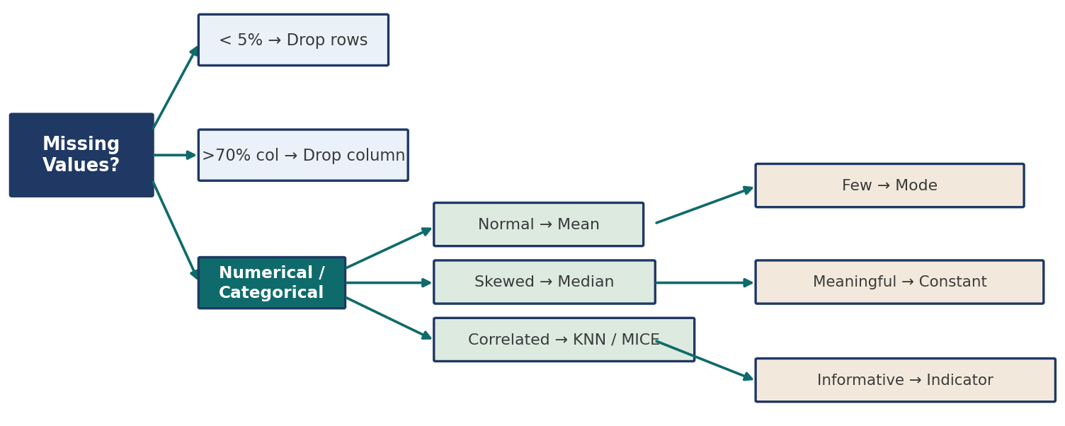

Algorithm Compatibility
Handles missing directly | Needs imputation first
XGBoost, LightGBM, CatBoost | Linear/Logistic Reg, SVM, KNN, Neural Nets, Decision Tree, Random Forest

2. MULTIVARIATE IMPUTATION
Missing values of one feature estimated using info from multiple other features.
KNN Imputer
Finds K most similar rows (Nan-Euclidean distance) & averages their known values to fill the gap.
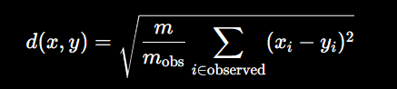
▪ Pros: uses feature relationships, more accurate
▪ Cons: costly, needs scaling, sensitive to K
Data w/ NaN → Find K-nearest rows → Avg known values → Replace NaN

MICE (Chained Equations)
Iterative, model-based: predicts each missing feature using the others in a chain, repeating until values stabilise.
Mean-impute all → Model predicts col A → then col B… → repeat till convergence
Missing type | MICE suited?
MCAR | Yes
MAR | Best suited
MNAR | Generally no

▪ Pros: uses relationships, flexible, improves w/ iterations
▪ Cons: expensive, model-sensitive, may not converge

3. HANDLING MIXED VARIABLES
A single column holding both numeric & categorical info, e.g. Cabin 'C22' → Deck 'C' + No. 22.
▪ Fix: split into two separate columns before encoding/scaling.
▪ Left as-is → hides patterns, blocks scaling/encoding.

4. WORKING WITH DATES & TIME
Raw date → Convert to datetime → Extract useful parts
Date parts | Time parts | Derived
Year, Month, Day, Weekday | Hour, Minute, Second, AM/PM | Date-diff, is_holiday, is_weekend, month-end
5. HANDLING OUTLIERS
5-number summary → shows spread of data, detects outliers, builds box-plot.
Stat | Meaning
Min / Max | Smallest / Largest value
Q1 (25%) | 25% of data below
Median (Q2) | Middle value (50%)
Q3 (75%) | 75% of data below

IQR = Q3−Q1 Lower fence = Q1−1.5·IQR Upper fence = Q3+1.5·IQR
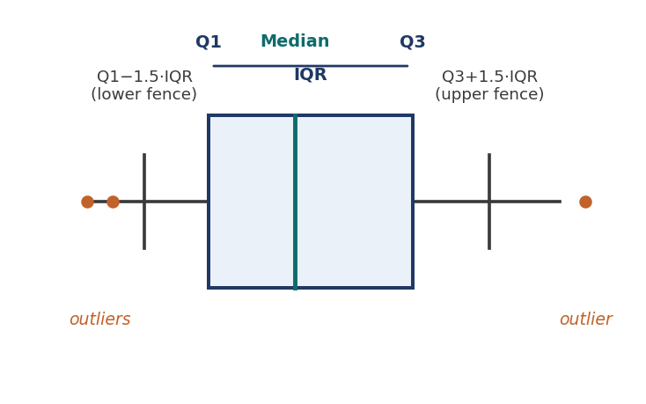
IQR is preferred over range — resistant to outliers.

Detection / Treatment Methods
Method | Best for
IQR method | Skewed data
Z-score | Normal distribution
Box plot | Visualisation
Percentile capping | Extreme values
Winsorization | Replace extreme values

▪ Ignoring outliers distorts the mean, inflates variance & reduces model accuracy.
▪ Tree-based models are largely robust to outliers/skew.

6. HANDLING IMBALANCED DATASET
Imbalance | Ratio ex. | Best approach
Mild | 600:400 | Usually no special handling
Moderate | 900:100 | Class weights / Resampling
Severe | 9900:100 | SMOTE / Ensemble / Cost-sensitive

Method | Use when
Random under-sampling | Large majority class
Random over-sampling | Small minority class
Class weights | Algo supports weights
Threshold tuning | Need higher recall
SMOTE | Create synthetic minority samples
Ensemble methods | Severe imbalance

▪ Never resample before train-test split → causes data leakage.
▪ Not used for regression problems.

SMOTE — Synthetic Minority Over-sampling
Pick sample → Find K-nearest nbrs → Choose neighbour → Interpolate
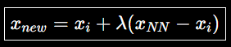
λ ∈ (0,1)
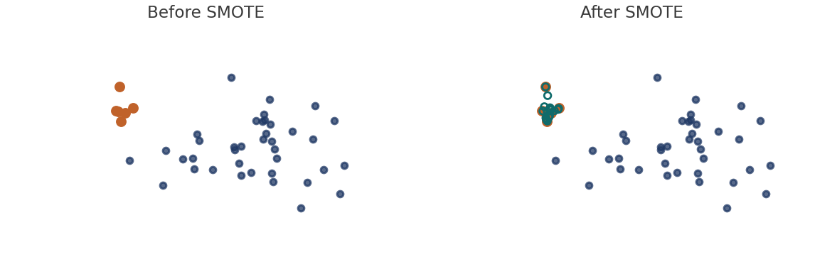
▪ Creates new synthetic points (not duplicates) → fixes over-sampling's lack of variance.
7. ENCODING CATEGORICAL DATA
Encoding | Best for
Label | Target labels
Ordinal | Ordered categories
One-Hot (OHE) | Nominal categories
Target-guided ordinal | High-card., correl. w/ target
Frequency / Count | Category frequency matters
Binary / Hash | High-cardinality / big data

OneHot(xi)=1 if xi=Cj else 0 | Ordinal: order = mean-target rank
▪ OHE → vectors orthogonal, no false ordinal relationship created.
▪ Target-guided: rank categories by mean(target), encode by rank.

8. FEATURE SCALING
 | Standardization | Normalization
Formula | z=(x−μ)/σ | (x−min)/(max−min)
Output | mean 0, std 1 | range [0,1]
Outlier sens. | Medium | High (Robust=low)

▪ Normalization types: Min-Max, Mean-norm, MaxAbs, Robust (uses IQR — least outlier-sensitive).
▪ Scaling never removes outliers, only rescales.
Outliers? Yes→Robust → No→Normal? Yes→Standardize → No→check algo needs

9. DATA TRANSFORMATION (SKEW → NORMAL)
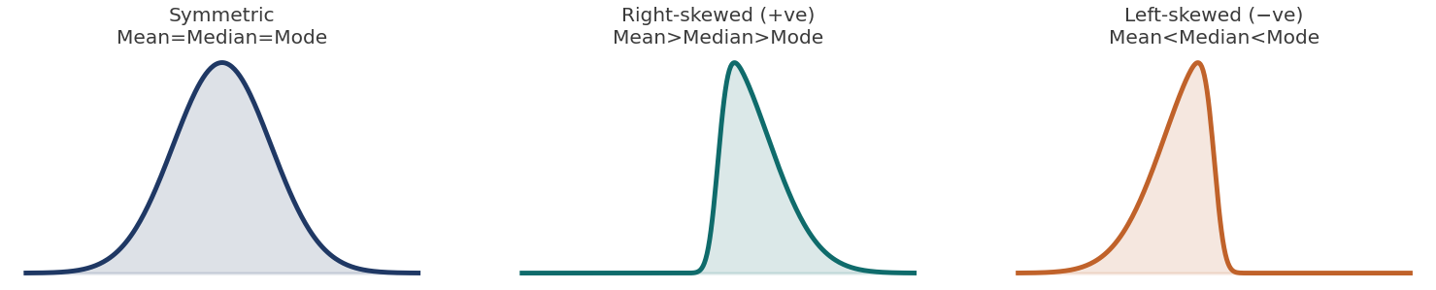
Skew | Mean vs Median | Fix
Symmetric | Mean=Median=Mode | —
+ve (right) | Mean>Median>Mode | Log, Sqrt, Recip., Box-Cox
−ve (left) | Mean<Median<Mode | Square, Cube, Yeo-Johnson

Box-Cox: x'=(x^λ−1)/λ, x>0 only | Yeo-Johnson: handles 0 & negatives too
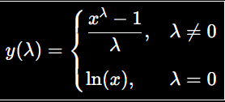
▪ Power Transformer auto-picks best λ → most normal-like, reduces skew & outlier effect.

10. BINNING & BINARIZATION
Type | Rule
Equal width | bin width=(max−min)/n_bins
Equal frequency | each bin ~same % of data
K-means binning | cluster-based bins
Binarization | x'=1 if x>threshold else 0

▪ Unsupervised binning is sensitive to outliers; custom binning uses domain knowledge.

11. COLUMN TRANSFORMER & ML PIPELINE
X' = [ T1(X_num), T2(X_cat), … , Tk(X_subset) ] (outputs concatenated)
Applies different preprocessing to different column subsets in one step — avoids repeated code & leakage.
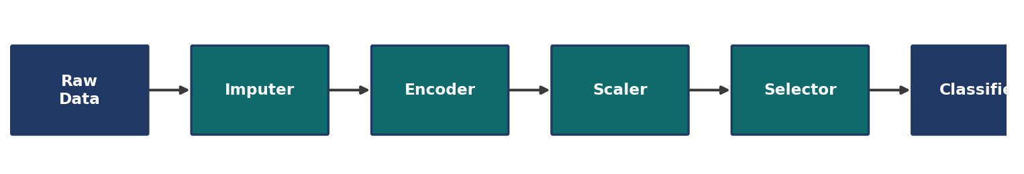
▪ Never fit() on test data — only transform() — to avoid data leakage.
▪ Pipeline = chain of transformers + final estimator; each step feeds the next.

